Transcendentalism Notes
Historical Context

Definition in your own words:

Philosophies/Beliefs/Characteristics
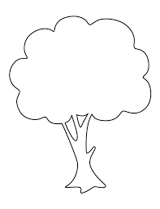
Key Figures

