Sungmin Ko
Mrs. Cossano
Journalism, period 4
May 20, 2020
Senior gown and cap pick up by drive-thru and photo submission
Photograph owned by Sarasota Lady Sailors.
On May 13, 2020, senior pick up their gowns and caps for graduation, using drive-thru system with masks and gloves during 12 o'clock to 3:00 p.m.. Because of Covid19 become more serious situation around the world and U.S., senior families and Skyline teachers and administrators decided to pick-up gown and caps ordered before the school closure for graduation, using drive-thru system with enough social distance. Drive-thru cap and gown pickup events were held in main entrance of Skyline High school, with counselor and teachers with wearing masks and gloves. Masks and gloves are worn by all teachers to prevent the possible infection by handing out caps and gown in-person. While Students and student's family picking up their caps and gowns, Skyline teachers and families are holding a graduation congratulating pamphlet at the entrance of the school gate, wearing mask and gloves, celebrating incoming students of 2020. Some parents brought their children with them to celebrate upcoming graduation for seniors. Graduation for seniors will be held on YouTube video, since all events such as prom, graduation ceremonies, and overnight parties are canceled because of COVID19. Instead of canceled ceremony and party, some teachers were wearing gown and caps and greeted seniors by car window sight. Basic items included for pick-up was graduation caps, graduation gown, graduation sign and diploma cover. Students needs to bring their ASB card to prove themselves who they are, and teachers brought assigned items for student's graduation. After gown and cap distribution, Seniors should take a picture of themselves with gown and caps on, and send it to SHS admission for graduation video. Email from Lucia Piotraszewski announced that photo submission is due May 20, and should be school appropriate. Here's the few requirements and rules for the Senior Graduation photo according to the announcement from Piotraszewski,
1. Photo in cap and gown, including a decorated cap.
2. No decorations of any kind will be allowed on gowns (except for school-issued honor cords, medals and stoles).
3. Seniors will be allowed to decorate their graduation caps. Nothing should be raised (flat decor only), nothing offensive and the decorations should celebrate hopes, dreams, passions, aspirations, and future plans and be entirely in good taste.
4. Please choose a non-distracting background for your photo.
5. Students should be holding diploma cover.
6. Same attire as if students were attending an in-person ceremony.
7. School have right to take the photo out if it is not appropriate.
If student doesn't want to be included in the celebration video, students should e-mail to registrar Heidi Hendrickson by May 20th. Graduation date will be June 12, 10 am to 2 pm, which is also drive thru to prevent the infections. Seniors will pick up yearbooks, department awards, souvenir graduation programs and tickets, and IB stoles. Staff will also be on the graduation date and cheering seniors on the tunnel. Textbooks and school materials will also be returned at the graduation date.
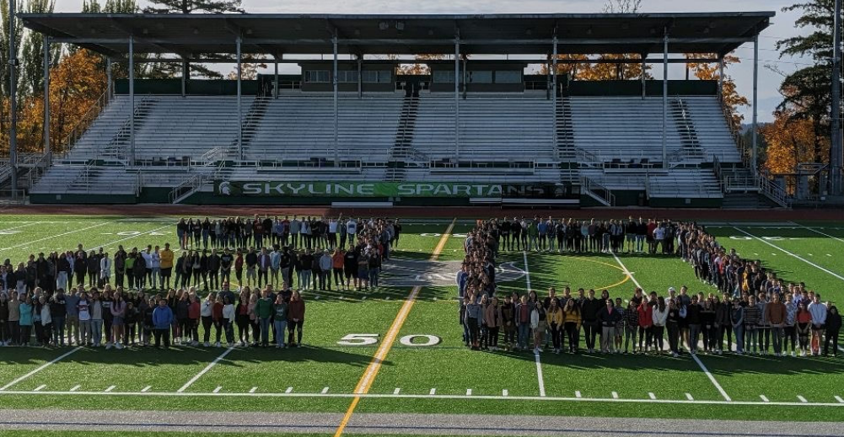
photo of Class of 2020, owned by SHS Class of 2020.

