Advice the class of 2020 would give to their freshman selves
By Abby Bacon

Happy quarantine Skyline! The Forum misses all of the amazing students during this time of quarantine and hopes everyone is staying home and staying safe. High school is a pivotal time of growth for kids and passions, hobbies, and lessons that are discovered during the four years. The amount of growth that occurs throughout the four years is amazing! The Forum asked the Skyline class of 2020 to give advice to their freshman selves, and here is what they had to say;

“Not care so much what people think! By senior year, almost everyone’s friends with each other, and the important thing you take with yourself in the future is your individuality. You’re the only you, so be proud of that and be yourself!”- Mansi Joshi

“Relax, take a deep breath and put things into perspective. Everything will work out how it is supposed to in the end”- Demetre Teodosiadis

“I would say to live each day of high school like its the last!”- Charlotte Howell

“I wish that I could have told my freshman self to cherish my friendships and the time I had in high school, even if it wasn’t always great. And I’d tell her please for the love of god, pay more attention to your studies rather than that boy who doesn’t like you back”- Ramya Rajasekhar

“You’re probably too young to be dating”- Atesha Banki

“Don’t be awkward and talk to people”- Ellie Holliway

“Go to all the games you can, its actually really fun to support your school”- Blake Abrahamsen

Many messages can be derived from the high school experience. A common theme throughout a few of the responses from our seniors is simply not to be afraid to be yourself. Highschool has taught many of the seniors that life is too short to worry about what other people think of you. People tend to underestimate how kind and good-natured that others can be. Every student at Skyline is so unique and wonderful and the absence of the class of 2020 will be greatly felt among the students next year.

Here are some lovely pictures of some of the class of 2020 graduates when they were only freshmen. It’s crazy how time flies and it is always so fun to look back at old pictures and see how people have grown.

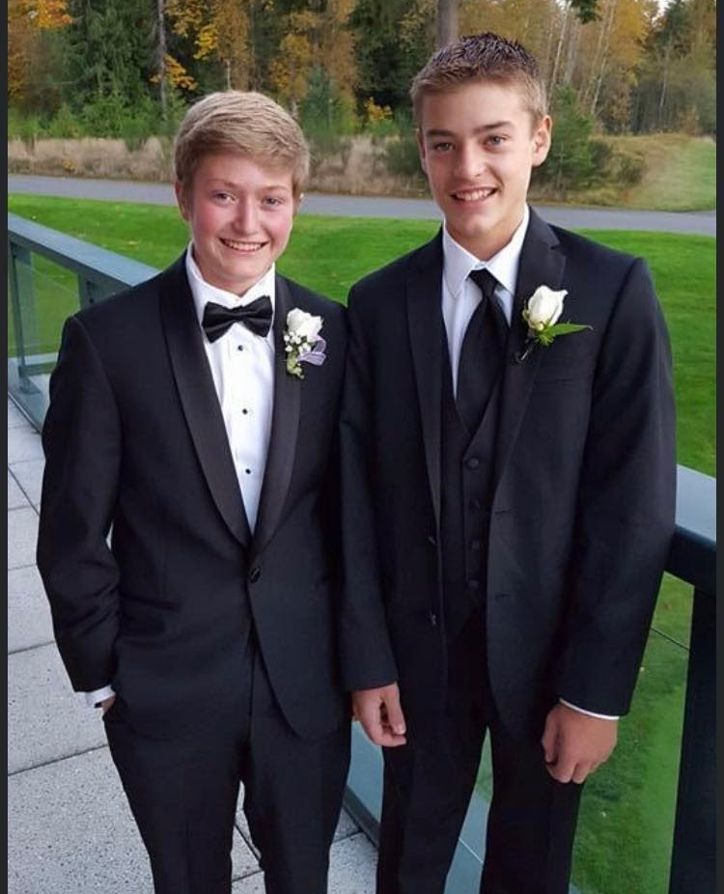

The four years that one spends in high school fly by extremely fast and soon the class of 2020 will be off to college or the many other adventures that each and every senior has in store for them. Thank you to the wonderful seniors for sharing knowledge and helping out the lowerclassmen with the daunting and scary experience that is high school. The time that every student spends in the welcoming and loving halls of Skyline is so special. The Forum will miss the class of 2020 so much next year and the halls will not feel the same without them.

