The Romantics
Definition (in your own words):
Historical Context

5 I’s

Philosophies/Characteristics
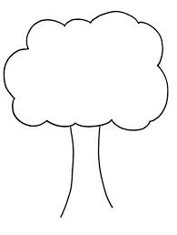Romantic Literature