F. Scott Fitzgerald’s The Great Gatsby (1925)
Essential Questions:
- Define the American Dream.
- Conclude what would make Nick a corrupt character.
- Determine who is to blame for the conclusion.
- How is the novel a reflection of the 1920s?
- Determine why the 1920s were impossible to sustain.
- Conclude the effects of Prohibition.
- Determine if jazz is an example of life imitating art or art imitating life.
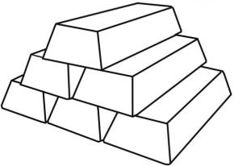

Socratic Seminar Questions (December 20th)
- Conclude the most important theme of Gatsby, and how Fitzgerald uses the characters and symbolism to develop the theme.

- Fitzgerald wrote, "You don't write because you want to say something, you write because you have something to say." What did he have to say in Gatsby? What was the biggest problem in 1920s society?

- The 1920s was the decade of ‘the flapper’, the young woman who exercised unprecedented freedom. Determine if Jordan Baker is a ‘flapper’.

- Fitzgerald returns several times to describe a decrepit optical products sign – the eyes of Doctor T. J. Eckleberg -- that hovers over "the valley of ashes." What does that sign represent? What do the faded eyes of Doctor T.J. Eckleburg symbolize? Is there a connection between this billboard and the green light at the end of Daisy's dock?

- Perhaps the novel's climax occurs when Gatsby confronts Tom in New York. Did Daisy's ultimate choice surprise you? Is it consistent with her character? Explain.

- Nick believes he is an honest, nonjudgmental narrator. Discuss the reliability of Nick Carraway as the narrator of The Great Gatsby.

