Verified______ Verified______ Verified______
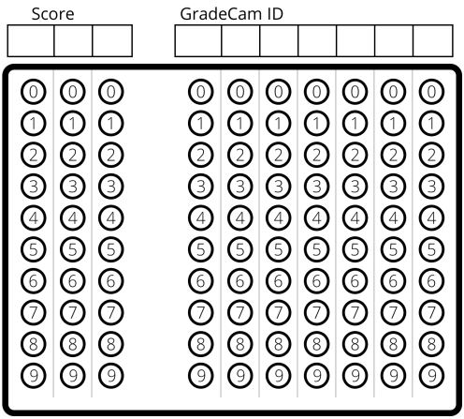

Verified______ Verified______ Verified______

Verified______ Verified______ Verified______

