High school advice for underclassmen
In the September of 2016, a group of kids stepped foot on an unfamiliar territory – high school. In the blink of an eye, four years have passed, and this group of kids are facing arguably the most uncertain time of their life. Although their upcoming journey seems foggy, but the path they came from is clear. The Forum decided to survey a few seniors. Here are some of the advice from fellow seniors for those students who are still in the midst of high school.
SPEND TIME DOING THINGS
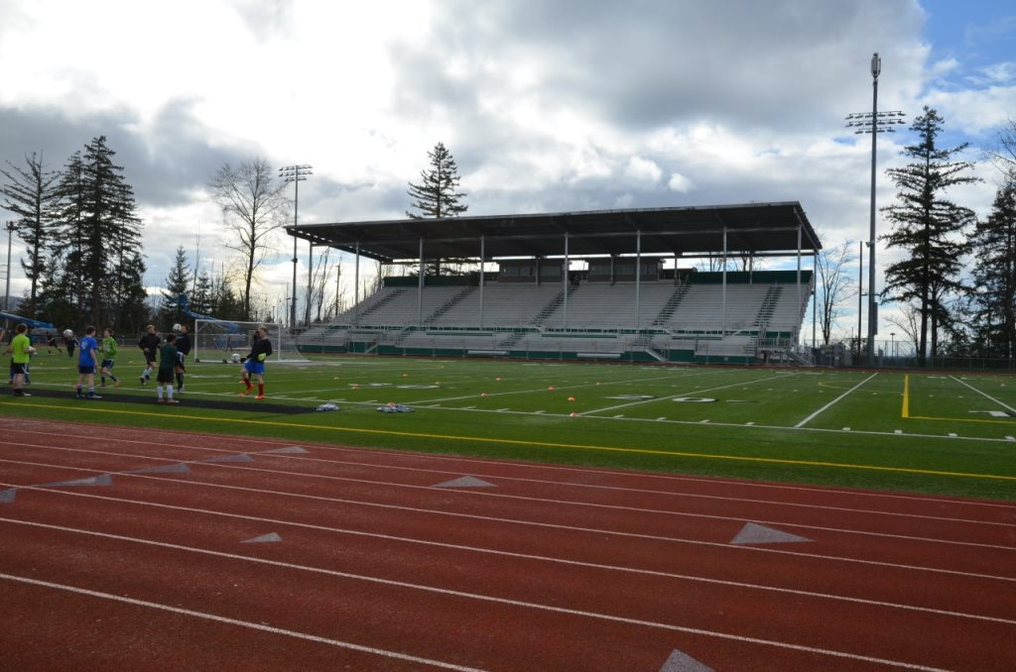
Sophomore and Junior year are the times when students start to find who they really are. These are the years to participate in extracurricular activities, such as sports, clubs, etc. A lot of students go home right after school every day to work on homework and watch Netflix. Of course, that is very important. However, that usually results in students after high school not knowing what to do, because they didn’t try enough things during their sophomore and junior days. There are many ways to get involved at school; clubs and sports don’t require a lot of effort and allow students to develop good relationship with others. By joining a surplus of clubs, students will then end up sticking to the couple of those that really interest them. In addition to having good grades and friends, having passion for something is also extremely important.
ENJOY LIFE
It might sound ridiculous to some people, but high school is great. Look at the graduating seniors, most of them are cherishing the memories they made. It’s not solely because of that their time was cut short due to the virus, but it is also because high school was actually a really great time for them. It might be hard to enjoy high school when tests, presentations, are coming back and forth. But, it is truly so important to just relax and appreciate the time with friends and family, while still enjoying the luxury of being a kid.
Other advice from graduating seniors:
- Research about post high school careers (college, jobs, army). Managers, admission office, and recruiters want people who know what they are applying for.
- Ask for help if needed. Do not be afraid to ask teachers, parents, or friends when struggling.
- Mistakes are fine – learn to recognize that life will always be better when things are learned through experience.
- Play videogames when bored
- Make the most out of the rest of high school.
- Exercise and maintain a good physical health.
- Do not be afraid to talk to new people.
- Help those who might be struggling. If someone is having a hard time with school, social life, or anything, it is always better to offer a helping hand than walking away from him/her.
- Do not try to skip assemblies, Thorsen will always be waiting in the front to catch people.

