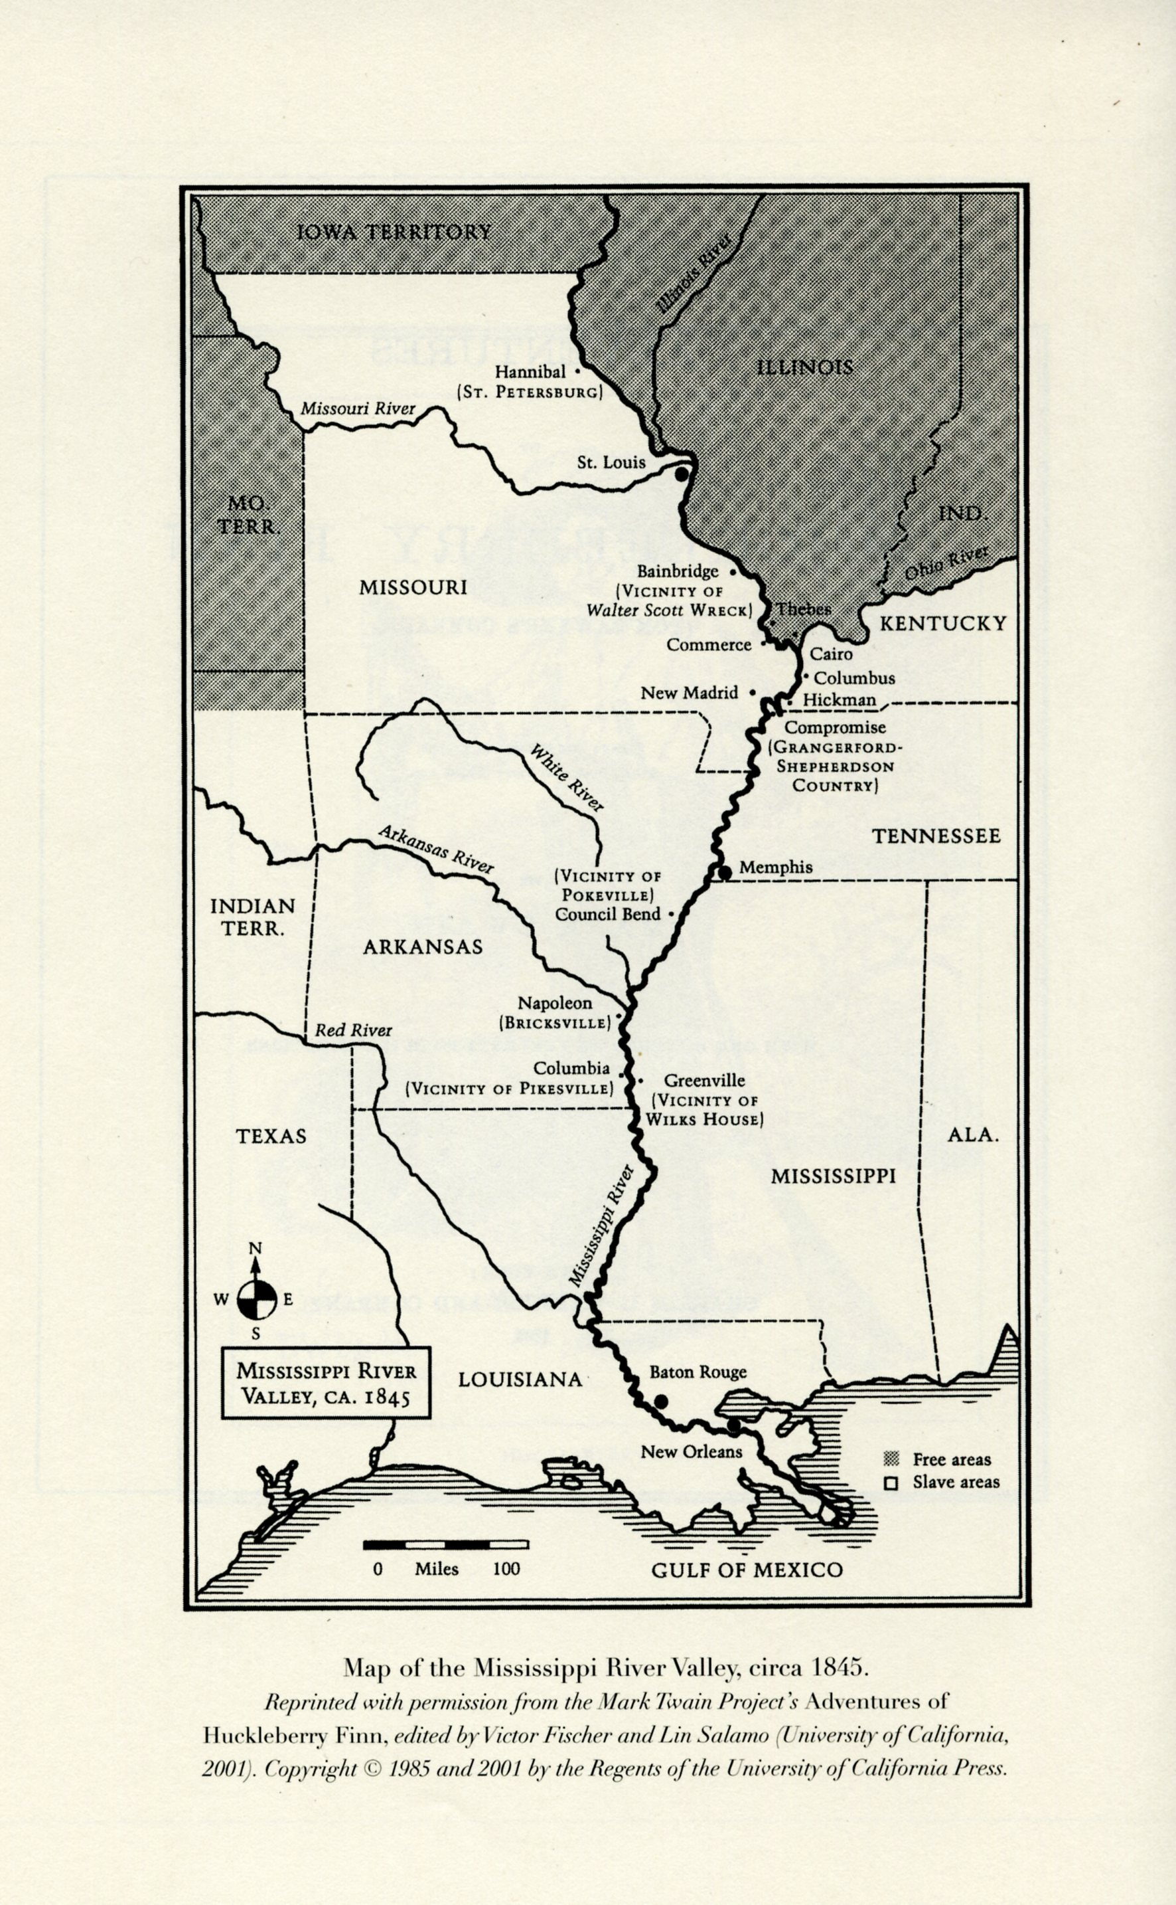
Woldendorp
River Illustration

For this assignment, you will need to plot out all the major story points for The Adventures of Huckleberry Finn. You will indicate points on the map of the Mississippi River, and write a brief description of the event on a separate sheet of paper. You will need to figure out where the events take place along the river. Use the novel to find out the names of the towns or areas where different events happened. This map is a map from the Mark Twain library, and is accurate to the late 1840s. It is what Twain used when writing the novel.
This needs to be done by each person, but you may work with a partner or in groups of three. I will be collecting the map and write up in a homework packet, and we will be working on this in class throughout the unit.
Some of the major plot points that need to be included (these are the minimum, you are encouraged and expected to add other events, and give specific details of what happened):
- Introduction
- Jackson’s Island
- Raft crash and robbers boat
- Huck dressing as a girl
- Grangerfords vs. Shepherdsons
- Duke and dauphin and all their nonesuch
- Wilks family
- Phelps farm and the selling of Jim
- Breaking Jim out of the shack
- Tom being returned, Jim being chained
- Conclusion….

