Hatfields and McCoys: An American Vendetta

With roots in the Civil War, the feud between the Hatfields and the McCoys continues to capture our imagination.
POSTED BY: Kim Gilmore
May 07, 2012

Note from Mr. M^{c}Cormick: [The Hatfield-McCoy feud reached its peak during a journalistic period known as “yellow journalism.” During this period the emphasis for newspapers (especially those owned by William Randolph Hearst), was to make money and sell newspapers. As a result of this push to increase sales, stories were embellished, exaggerated, and sensationalized. This article presents the facts as best it can, and attempts to omit the sensationalism, but I’m sure that as you read, you can see points where a “creative” journalist could really run with a story]
Hatfields and McCoys—their surnames evoke visions of gun-toting vigilantes hell-bent on defending their kinfolk, igniting bitter grudges that would span generations. Yet many people familiar with these names may know little about the faded history of these two families and the legends they inspired. Who were the Hatfields and McCoys, and what was the source of their bitter clash?
…
Untangling the story of these feuding families is not simple. Lore has it that the feud was sparked by many different events—a stolen hog, a star-crossed romance, a Southerner who dared fight for the Union during the Civil War, and a heated election-day brawl drenched with alcohol. Each of these events has been cited as the source of the conflict. In truth, all of these events may have contributed to the deep resentments between the families that erupted into the historic feud that transpired against the changing canvas of the Appalachian mountain community in the last decades of the 19th century.
The Hatfield-McCoy conflict had geographical as well as social and political dimensions. Both families lived along the Tug Fork of the Big Sandy River, which snaked along the boundary between Kentucky and West Virginia. This unique location would later stoke the flames of the feud as authorities in each state marshaled their powers to try to bring justice to those who they felt were wronged. While both Hatfields and McCoys lived on either side of the river at various times, the majority of Hatfields resided in West Virginia’s Logan County while most of the McCoys lived on the Kentucky side in Pike County.
During the most heated years of the feud, each family was ruled by a well-known patriarch. William Anderson Hatfield, known as Devil Anse, had the appearance of a backwoods, rough-hewn mountain dweller. Born in 1839, he had served on the Confederate side during the Civil War from 1861 to 1863, becoming a first lieutenant. Like many mountain leaders, Anse is thought to have deserted the official military ranks and returned home to resume leadership of a local militia unit known as the Logan Wildcats. Bands such as the Wildcats, known as “irregulars,” were invested in protecting their own communities from Union invasion even more than they were dedicated to helping the Confederate Army achieve ultimate victory. They fiercely protected their own communities from attack.
By the 1870s, Devil Anse was an increasingly successful timber merchant who employed dozens of men, including some McCoys. While Anse struggled with land disputes and debt, he knew the legal system well and was a respected budding businessman. In the years after the Civil War, the Tug Valley was perched on the precipice of change, as the market economy started to penetrate Appalachia for the first time. Anse, like many of his contemporaries, was caught between two worlds.
Up to this point, the Tug Valley had remained isolated from the market economy that had transformed other communities. With rugged terrain that had not been incorporated into railroad routes, the area was prone to provincial relations and a seemingly static social sphere. By the time the feud reached high tide, there was increasing interest among industrialists to develop the region. Lawlessness was seen as an impediment to these changes.
On the other side of the feud stood Randall “Old Ranel” McCoy. McCoy, like Devil Anse, had served on the Confederate side during the Civil War and had deserted early and returned home to his family. Though not as prosperous as Devil Anse, Old Ranel owned some land and livestock. And although he had a reputation for being somewhat difficult and lacking a sense of humor, McCoy was considered an upstanding member of the community. Both families lived in simple log dwellings with just a few rooms.
Devil Anse and his wife, Levicy, had more than a dozen children, as did McCoy and his wife, Sarah. Both families had complex kinship and social networks, and their families sprawled across the Tug Valley. In her detailed account titled Feud: Hatfields, McCoys and Social Change in Appalachia, 1860-1900, historian Altina Waller describes such Appalachian family networks. Family loyalty was often determined not only by blood, but by employment and proximity. When one talks of the Hatfield-McCoy feud, then, it is important to remember that the families were often intertwined and their networks included employees who worked for Devil Anse, for instance, or close friends who lived nearby. The families even intermarried and sometimes switched family loyalties.
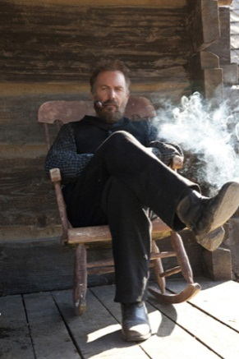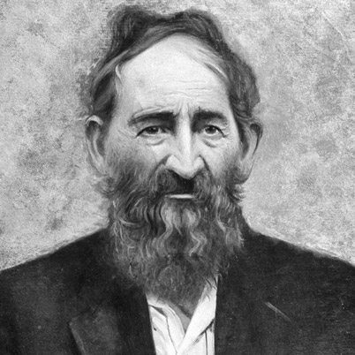
Devil Anse Hatfield, Civil War leader, family patriarch, and possible leader of the Logan Wildcats, as portrayed by Kevin Costner in the History miniseries (left) and an actual photo (right)

One of the first harbingers of the feud to come took place in 1865 when Asa Harmon McCoy was murdered by the Logan Wildcats after he returned from the Civil War. Asa Harmon had served in the Union Army, and came home branded as a traitor. According to most accounts, members of the Logan Wildcats paid Asa a visit upon his return, warning him that he was in jeopardy. Later, they tracked him down in a cave where he was hiding and killed him. While some have surmised that his murder set the stage for the feud, most historians now see this incident as a stand-alone event. There was consensus in the community that Asa Harmon was an outcast even amongst his own family because of his Union sympathies.
Yet the Civil War backdrop did play an important role in shaping life in the Tug Valley. Abundant resources—human, civic, and financial—were allocated toward the war. Many small towns were thrust into chaos, and soldiers returned home with bitter resentment and tainted by warfare. In counties like Logan and Pike, people also were used to taking the law into their own hands. Vigilante justice was not uncommon in areas without a fully developed system of law and order.
An accumulation of small grievances and scuffles between Hatfields and McCoys started to build in the 1870s. One of the most lasting explanations for the Hatfield-McCoy tensions is traced back to a dispute over a single hog. In 1878, Randall McCoy accused Floyd Hatfield, a cousin of Devil Anse, of stealing one of his pigs. At the time, hogs were of great value, and though they often foraged in unbounded areas, each family marked their hogs on the ear with a unique brand to establish ownership.
Floyd Hatfield lived on the Kentucky side of the river, so when the case against him went to trial, it took place in McCoy territory. The judge, however, was also a Hatfield. Judge Anderson “Preacher Anse” Hatfield, Devil Anse’s cousin, presided over the trial, which included an equal number of Hatfields and McCoys as jurors. The star witness, Bill Staton, was a nephew of Randall McCoy. Staton’s sister had married a Hatfield, so his loyalties seemed slanted, despite his lineage. Staton testified that he had seen Floyd Hatfield mark the hog, proving that he owned it. The McCoys were infuriated when Floyd Hatfield was cleared of the charges against him, and they never forgave Bill Staton.
Years after the hog trial, in June 1880, Bill Staton was violently killed in a fracas with Sam and Paris McCoy, nephews of Randall. While Sam stood trial for the murder, he was acquitted for self-defense reasons. It was rumored that Devil Anse had asked that Sam not be tried, given what had been relatively calm relations between the families after the hog incident. Yet the sting of the trial and its aftermath continued to fester, producing tensions that would later give way to escalating violence.
Just as the flames that raged after Staton’s murder were starting to die down, a heated affair of a different sort was set ablaze. Johnse Hatfield, 18-year-old son of Devil Anse, had a reputation as a sharp ladies man with a swagger in his step. At the time, local elections were social gatherings in which community members would get together, debate, drink, and engage in merriment. On one such election day in 1880 at Blackberry Creek in Pike County, Johnse encountered Roseanna McCoy, Randall’s daughter. According to accounts, Johnse and Roseanna hit it off, disappearing together for hours before heading back to Devil Anse’s homestead. Supposedly fearing retaliation from her family for mingling with the Hatfields, Roseanna stayed at the Hatfield residence for a period of time, drawing the ire of the McCoys.
Although they certainly shared a romance, it rapidly became clear that Johnse was not about to settle down with Roseanna. Several months later, he abandoned the pregnant Roseanna, who had no choice but to return home to her family. Most historians believe her baby died in infancy of measles. Johnse, meanwhile, quickly moved on. In May 1881, he married Nancy McCoy, Roseanna’s cousin. According to the romanticized legend, Roseanna was heartbroken by these events, and she never recovered emotionally.
While the legend of the Hatfield-McCoy feud often mentions the ill-fated affair between Johnse and Roseanna as a major turning point, his marriage to Nancy McCoy seems to cast doubt on his actions as a prime instigator in the feud. Regardless, the romance certainly did not improve the tense relationship, which continued to simmer between the families. Additional small-scale conflicts between various branches of the Hatfield and McCoy families continued to mount. Such seemingly minor infractions as unpaid debts escalated into violence. At every turn, both Hatfields and McCoys seemed willing to let the feud go, but peace never came.
After he left Roseanna, Johnse was a target of the McCoys. Tolbert, a son of Randall, had become a special deputy in Pike County. Tolbert went after Johnse for carrying a deadly weapon, even though men at the time frequently carried guns for hunting. Tolbert took him into custody and threatened to lock him up and throw away the key, but Johnse was rescued soon thereafter by Devil Anse and a posse of supporters. Tolbert countered by trying to have some of the other Hatfields arrested, but found little support for his efforts. Tolbert’s actions indicated that relations between the families were becoming heated.
The real turning point in the feud, according to most historical accounts, occurred on another local election day in August 1882. Three of Randall McCoy’s sons—Tolbert, Pharmer, and Randall Jr.—ended up in a dispute with two brothers of Devil Anse. The Hatfield brothers, Elias (also known as “Bad Lias”) and Ellison, had gone to the election site to socialize. Men on both sides were reported to have been drinking heavily. Looking for a fight, Tolbert McCoy confronted Bad Lias over a small amount of money he said Lias owed him for a fiddle. The confrontation turned into a brawl—the three McCoy brothers and Lias and Ellison Hatfield ended up in a blood-soaked clash.
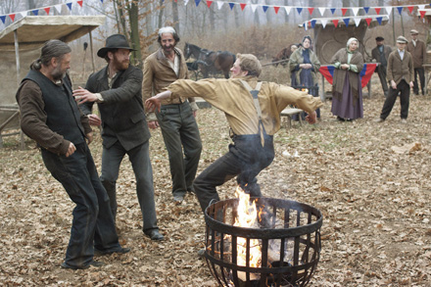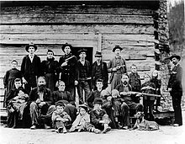
Still shot from the History miniseries depicting the election day dispute (left) and a photo of the Hatfield Clan, with Devil Anse Hatfield (seated, second from left)

The election-day fight snowballed into chaos as one of the McCoy brothers stabbed Ellison Hatfield multiple times and then shot him in the back. All three McCoy brothers ran from the scene. The Hatfields rushed to try to save Ellison, who was taken on a makeshift stretcher to the home of a local man and then later back to Logan County. Meanwhile, Kentucky authorities apprehended the McCoys. Devil Anse called together a group of supporters who found the McCoys and apprehended them from the guards. After reportedly threatening to kill the brothers if any of the other McCoys intervened, the Hatfields forced the brothers into a skiff and took them across the Tug River into West Virginia. Amidst pounding rain, they entered a schoolhouse and posted guards on each door.
Sally (Sarah) McCoy, mother of the McCoy boys, arrived at the schoolhouse and begged the Hatfields for mercy. The Hatfields allowed her to see her sons, and she and her daughter-in-law Mary Butcher (Tolbert’s wife) sobbed and pleaded with the Hatfields for their release; the captors seemed to be holding the McCoys until they learned the fate of Ellison Hatfield. Shortly thereafter, the Hatfields received word that Ellison had succumbed to his wounds. Incensed and seeking revenge, the Hatfields transported the McCoy boys back to Kentucky and bound them to some pawpaw bushes near the river bank. Within minutes, they fired more than 50 shots, killing all three brothers.
Funerals took place on both sides of the river as the families grieved. Though the Hatfields might have felt their revenge was warranted, Judge George Brown of the Pike County Circuit Court on the Kentucky side of the river assembled a grand jury that returned indictments against 20 men, including Devil Anse Hatfield, two of his brothers, his sons Johnse and Cap, Selkirk McCoy (a Hatfield friend), and several other men. Despite the charges, the Hatfields eluded arrest. They usually traveled in well-armed bands if and when they entered Kentucky. At the time, the authorities had little interest in over-stepping their jurisdiction to hunt down the Hatfields on their home turf.
If the Hatfield-McCoy story ended there, it most surely would have receded into the past like the countless other family feuds that dotted the Appalachian landscape. Yet this was hardly the end of the drama. The McCoys boiled with anger about the murders, outraged that the Hatfields walked free. For years, Randall McCoy attempted to push the issue and force Kentucky authorities to go after the Hatfields and bring them to justice.
Enter Perry Cline, an eager Pikeville attorney who was married to Martha McCoy, the widow of Randall’s brother Asa Harmon. Cline, like many Pikeville locals, was invested in promoting the region as an industrious, resource-rich area ripe for development. The existence of vigilante rogues like Devil Anse Hatfield and his brood damaged the area’s reputation, and Cline was determined to shut down their operations and make the region safe for timber and coal industrialists. (Just a few years later, the arrival of the railroad set the stage for the region to become one of the most prosperous coal-producing communities in the nation.)
Cline, perhaps not coincidentally, had also lost a lawsuit against Devil Anse years before over the deed for thousands of acres of land. Historians surmise that Cline may have been looking for his own form of revenge when he decided to pursue the case against the Hatfields in the mid-1880s. He was joined in his mission by Pike County Deputy Sheriff “Bad” Frank Phillips, a volatile local private detective who had a reputation for being a heavy drinker with a violent streak.
Using his political connections with Kentucky Gov. Simon Bolivar Buckner, Cline had the charges against the Hatfields reinstated; he announced rewards for the arrest of the Hatfields, including Devil Anse. Meanwhile, West Virginia Gov. E. Willis Wilson wavered on whether to cooperate with Kentucky authorities and allow them to hunt down and arrest the Hatfields in West Virginia based on their original indictments. He finally decided against allowing them to invade his state, claiming they did not have proper extradition papers, but by that time Phillips and other bounty hunters were even more determined to jail the Hatfields.
With the pressure-cooker gathering steam, the media started to report on the feud in 1887, fanning the flames of the upheaval. In those accounts, the Hatfields were often portrayed as violent hillbillies who roamed the mountains stirring up violence. Reporters arrived in the Tug Valley from far and wide to capture the drama of the feud, and the violence in Appalachia made headlines nationwide. The sensational coverage planted the seed for the rivalry to become cemented in the American imagination. What had been a local story was becoming a national legend.
The Hatfields may or may not have been paying attention to these stories, but they were certainly paying attention to the bounty on their heads. In an effort to end the commotion once and for all, a group of the Hatfields and their supporters hatched a plan to attack Randall McCoy and his family.
Led by Devil Anse’s son Cap and ally Jim Vance, a group of Hatfield men and their allies arrived at the McCoys’ home on New Year’s Day in 1888. The unsuspecting McCoys were ambushed by the Hatfield gang, who set the cabin on fire. Randall fled, escaping into the woods. His son Calvin and daughter Alifair were killed in the crossfire; his wife Sarah was left badly beaten—including a crushed skull. According to legend, the scene the Hatfield party left behind was grisly. Randall found Alifair dead outside the home, her hair frozen into the ground. The house was destroyed by fire.
The atrocious nature of the attack shocked even those in the Tug Valley who were used to the feuding. The Hatfields had terribly exacerbated the situation. A few days after what became known as the “New Year’s Massacre,” Phillips and a group of men chased down Jim Vance and Cap Hatfield. Vance ended up dead; rumor had it that Phillips put an extra bullet in Vance’s head for good measure. Phillips and his supporters had managed to round up nine Hatfield family members and supporters and hauled them off to Pikeville County Jail.
Although they may have agreed the feud had gone too far, West Virginia officials were outraged by the Kentucky posses that continued to swarm through Logan County. Finally, groups from both sides confronted one another at Grapevine Creek in West Virginia. Dozens of shots were fired in this cataclysmic showdown. Though only one person was left wounded and another dead, authorities in both states were exasperated by the negative attention. Governors of both states sent attorneys to the U.S. District Court in Louisville to finally decide if and where the Hatfields could be tried.
All sorts of legal permutations unfolded, including the transportation of the Hatfields to Louisville, creating a circus-like atmosphere. The issues at stake were whether the Hatfields were arrested illegally and whether they could be tried in Kentucky. Eventually, the case went all the way to the U.S. Supreme Court. National newspapers like The New York Times and the Chicago Tribune were magnetized to the story, and they reported extensively on the feud and the family members involved. Finally, the Supreme Court decided the Hatfields being held in custody could be tried in Pike County.
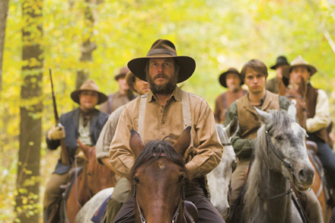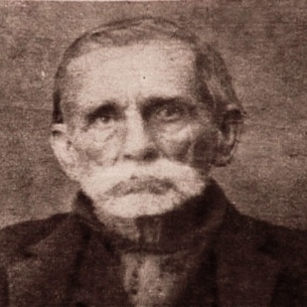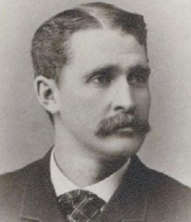
Randall McCoy, civil war soldier and family patriarch, as portrayed by Bill Paxton in the History miniseries (left), later in life (center) and in his younger days (right)

The Supreme Court decision also unleashed bounty hunters who had been champing at the bit to apprehend more Hatfields, and bands of men on horseback roamed through Logan and Pike counties. Although many of them wanted to capture the purported family leader, Devil Anse, there never was clear evidence of his actual involvement in the violence that took place. Some argued that Devil Anse kept a distance from the feud in order to continue running the family businesses.
Finally, the trials against the Hatfields started in early 1889. By this time, the fury had started to subside and the feud itself seemed to have cooled. Sarah McCoy gave emotional testimony about the murder of her daughter Alifair, and other witnesses testified about the barbarous behavior of the Hatfields over the course of a decade. In the end, eight of the Hatfields and their supporters were sentenced to life in prison. Ellison Mounts, who was believed to be the son of Ellison Hatfield, was sentenced to death. Mounts, nicknamed “Cottontop,” was known to be mentally challenged, and many viewed him as a scapegoat even though he had confessed his guilt.
Although public executions were against the law in Kentucky, thousands of spectators gathered to witness the hanging of Ellison Mounts on Feb. 18, 1890, in Pike County. The gallows were placed at the bottom of a hill, allowing onlookers to view Ellison as he was executed. He was the last person to be executed in the county. Reports claim that his last words were, “They made me do it! The Hatfields made me do it!”
As the feud faded, both family leaders attempted to recede into relative obscurity. Randall McCoy became a ferry operator in Pikeville. In 1914, he died at the age of 88 of burns suffered in an accidental fire. By all accounts, he continued to be haunted by the deaths of his children.
Devil Anse Hatfield, who moved his family up the river to Main Island Creek, had defended his name during the trials. He testified that “every man in Logan County who knows me will tell you that I am a peaceful, law-abiding man, and no man would ever say I ever told a falsehood.” He tried to rescue his good name in another fashion in 1911 when, at the age of 73, he was baptized for the first time. Though Devil Anse had long proclaimed his skepticism about religion, he was born again later in life. Some historians assume he was influenced by the progressive industrialism that swept the Tug Valley as the timber and coal industries flourished.
When Devil Anse died in 1921, hundreds of people gathered for what was the largest funeral in Logan County history. Both local and national newspapers covered the death of the legendary family leader who was remembered as a Civil War veteran and a good provider to his family and employees. The Charleston Gazette reported, “The casket, covered with flowers, was borne around the mountain side by twelve strong-men. Rev. Green McNeely…spoke a few simple words, not of the dead man, but of the lesson of death, and loosing flowers upon the coffin, now incased in a steel vault, pronounced the words: ‘Earth to earth, ashes to ashes, dust to dust.’”
………………………………………………………………………………………………………………………………………………………………..
Although Devil Anse may have been remembered in some circles as a brave leader, the dark stain of the feud continued to hang over Appalachia. The extra-legal justice adopted by mountain families may have been ingrained in communities for a period of time, but by the turn of the 20th century a new spirit of industrialism and transformation reverberated throughout the Tug Valley. Industrial leaders were embarrassed by the ongoing attention generated by the feud.
For many valley families, the unrest did not conclude with the execution of Ellison Mounts. As the area became one of the largest coal-producing regions in the territory, workers started to organize and form unions to protect their rights. Laborers who joined the United Mine Workers of America were threatened by local agents and evicted from their homes. The infamous May 1920 Matewan massacre, in which many local citizens were gunned down by coal industry detectives, took place in Hatfield-McCoy territory. The event catalyzed decades of strife between coal miners and corporations. Members of the Hatfield and McCoy families were drawn into the drama, with a new foe in the form of big industry.
The bad blood between the Hatfields and McCoys declined after the turn of the century. In 1944, a LIFE magazine article subtitled “Famous Feuding Families Now Live Together in Peace,” depicted the two families living in harmony. And though many family members had moved away and established lives elsewhere, both families still had roots in the region and many resided in the area. One photo showed two young women named Shirley Hatfield and Frankie McCoy side-by-side in a factory making uniforms for the World War II effort. By 1979, the feud even took on a humorous tone when members of both families appeared together on the TV game show Family Feud to duke it out in more congenial terms.
Today, despite the fact the conflict has long since subsided, the names Hatfield and McCoy continue to loom large in the American imagination. Were these mountain families gun-obsessed brutes or everyday humans attempting to protect their own in terms that were acceptable in their context? Was one family more responsible, or were they both guilty of violence that crossed the lines of decency? Was justice served, or was the feud blown out of proportion by yellow journalists and legal authorities acting in their own self-interest?
Kim Gilmore is a staff historian and director of corporate outreach for HISTORY®/A+E Networks.

Events and Grievances by Family
Document the role of each family in each event, and/or how the families reacted. How did the families feel as a result of the events?
Hatfield view | Event | McCoy View
 | Death of Asa Harmon McCoy
 | Hog Trial
 | Staton’s Death
 | Johnse and Roseanna
 | Election day fracas and Ellison Hatfield
 | Hatfield Arrest and Execution of Ellison “Cotton Top” Mounts

Final Activity: Since yellow journalism was all about embellishing a story, select an event from the list above and make be your own yellow journalist. Create a headline that will grab someone’s attention, choose 3 details about the event and embellish them, in one sentence each, to make the story more sensational. You should not lie or give false information, so use words that are open to interpretation; example, a small fender bender in the parking lot could easily become a “Mangled mess of steel and fiber glass, thankfully no fatalities.”

