Dear Freshmen....

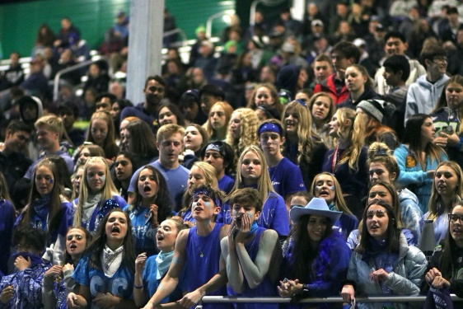
High school, a time of making memories, going to school dances, hanging out with friends and going to football games. Every year students get closer and closer to experiencing their senior year, the best year of high school. However, for the class of 2020, seniors across the world didn't get to experience the excitement of prom, graduation, and other senior activities that they will never have the opportunity to experience again. Since current freshmen and underclassmen students have the opportunity to have a memorable high school career, it is important to remember to live life to the fullest.

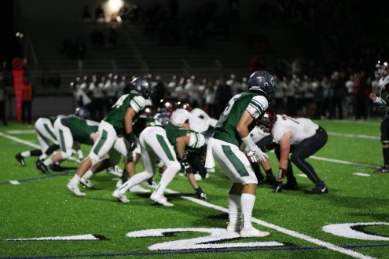
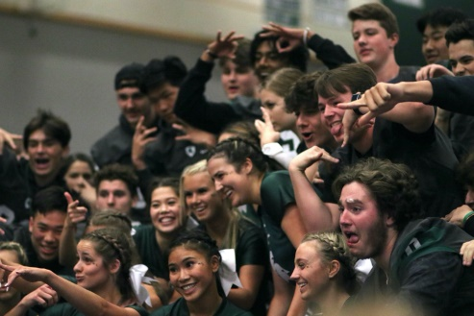
Throughout high school there are innumerable opportunities to hang out with your friends, make memories, and to show off your school spirit. A great way to kick off the beginning of the school year is attending football games. Dress up with your friends and cheer the team on from the stadium. It is a great way to show off your school spirit and hang out with your friends on a Friday night. The Forum interviewed a select number of seniors and they all agreed that attending school dances were the most memorable events at Skyline. My advice to the freshmen class is to go to all of the dances every year, as students will regret not going in the future. Get a group of friends together, dress up, and have a good time. Students don't need a date or a group to go to a dance and have fun. Another easy way to connect with your peers and to show your school pride is to dress up for spirit days. A couple of weeks during the school year ASB puts together a fun week of different ways to dress up, It is as easy as wearing ones pajamas to school. Spirit days are exciting, entertaining, and a great way to connect with staff and students.
Skyline seniors posing for a picture during the roll call at the homecoming assembly
Skyline students cheering on the football team at the weekly Friday night games

High school is a great time to explore new hobbies, career paths, and interests which is why underclassmen should take advantage of this time to try new things. If there is one thing that freshmen students should do is sign up for new classes and clubs that they would not normally take. Attend some club meetings, meet some new people, and sign up for some fun electives. You will learn some exciting new skills and who knows it could end up being your new favorite hobby!
The Skyline varsity football team playing one of their amazing Friday night games!

The last four years before graduation is such an exciting time to meet new people, try new things, and create amazing memories. The graduating class of 2020 did not get to experience most of senior year but still had an amazing four years. Underclassmen, do what is possible in high school, explore new things, and enjoy the time surrounded by friends and family. Attend every sports games, assembly, dance, and other school events because later it will be missed and students will regret not going. Make the most out of high school because the memories that are created, will never be forgotten.

