Character Chart
Who are the characters (people) in The Great Gatsby?
Character Name | Their role in the story (relationships) | Describe them (looks, age, boy or girl, rich or poor, how do they act)
Nick Carraway
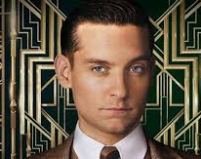
Jay Gatsby
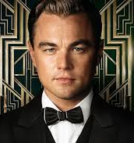
Daisy Buchanan
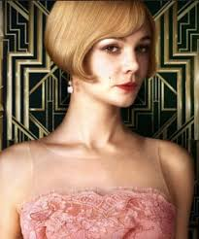
Tom Buchanan
Jordan Baker
Myrtle Wilson
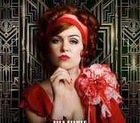
George Wilson
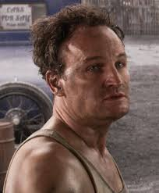
Meyer Wolfsheim
