Dark Romantics
Definition in your own words:

Philosophies/Beliefs
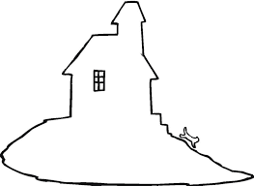 Literature 