Senior Athletes Advice
Although Skyline’s spring sports ended a little earlier than a lot of people would have hoped, there's always next year for the juniors, sophomores, and freshmen. This spring season goes to show that not all games are guaranteed and that as an athlete you should play every game like it is your last. Skyline High School has a wide variety of sports for all different types of athletes. Some of the sports that Skyline offers are football, boys’ soccer, girls’ soccer, wrestling, tennis, gymnastics, boys basketball, girls basketball, and golf.

The Forum asked current Skyline senior athletes for their advice on what the underclassmen would have for the underclassmen.

“I'd say my advice to younger athletes is not to be afraid to take risks in your sport. teams are super competitive and the more you put in, the more you’ll get out of it. Also, don't shy away from the older kids, the closer you get with your teammates, the stronger your team bond will be and that just makes everything so much better” - Emma Morgan

“Always keep working in the weight room and in practice and keep a positive attitude, cause your coaches will notice, and your name is going to be called when someone gets hurt or they need a sub. “- Sarath Kakani

“Take advantage of unofficial summer practices and spend as much time as you can trying to get to know the team through training.” - Delbar Darvish

“Your time playing high school sports flies by faster than you’d think. Don’t put too much pressure on yourself, have as much fun as possible and play every game like it could be your last.” - Marques Ovena

“High school football is something different, you’ll never have an opportunity to play with all your best friends and the kids you grew up with again. It’s something that’s hard to cherish in the moment since time seems to move so slowly when you're in the moment, but my best advice would be to love and hold on to every moment you have with those friends, on and off the field. The ones who look back fondly on their high school days aren’t always the ones who won championships but the ones who left no regret in the decisions they made, the ones who truly pushed themselves and made the most of the relationships they made throughout they’re seasons. High school football may not be forever but the bonds, friendships, and memories you make can be.” - Grant Wedeberg

“Definitely don’t get lazy in the off-season, put in the hard work then and when the season comes, you will thank yourself.” - Jack Randall
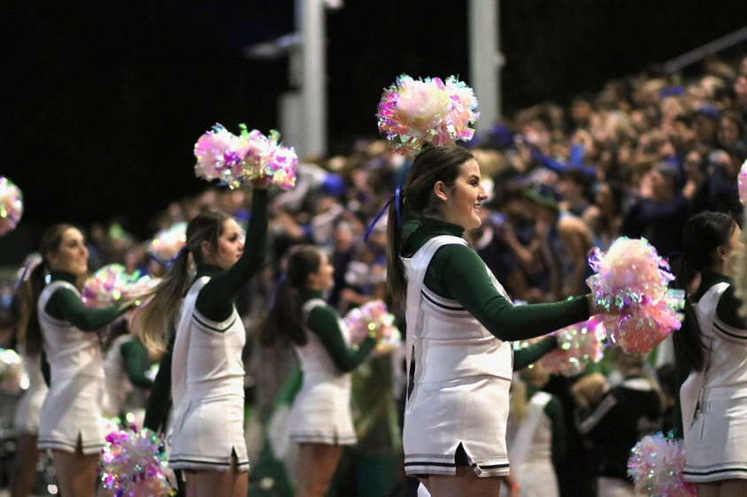
“Take your season slow and have fun I guess especially after this weird year we’ve had it could be over before you know it right. I mean I personally never imagined having this sort of situation nor did I imagine I’d break my collarbone and I’d be out half of my senior season. senior year is by far the best season and the most exciting and scary thinking about college but take your time getting to it. take in the little moments. I’ll always remember traveling to Gonzaga prep freshman year or I’ll remember the last football game I ever cheered at against Woodinville at Pop Keeney. the good things take time so don’t rush it.” - Katie Baker
Skyline cheerleaders cheering
Photo courtesy of Halle Halvorsen
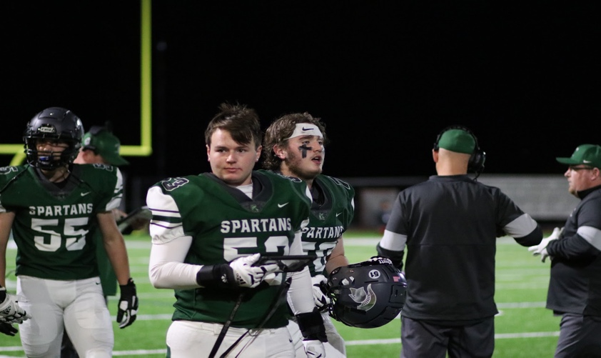
“Advice that I would give the underclassmen athletes is never quit my sophomore and junior year were so tough with school and doing sports it was hard but playing sports throughout high school it develops a character out of you it pushes you to your limits you make great memories and friendships that will last a lifetime and all that hard work you put in for that sport isn’t just for that
Skyline football players exiting the field. Photo courtesy of Halle Halvorsen
sport down the road you’ll realize you have the work ethic to push yourself no matter where the future leads you as many coaches say you need to battle through adversity and by doing that you work with your teammates as a cohesive unit to achieve that so with that in mind if there’s one thing I can leave skyline with is first if you’re thinking about quitting don’t I know it may seem hard but you got it just dig deep and second if you’re thinking about playing a sport but still questioning it do it you won’t regret it.” - Garret Steinmetzer
Skyline football players exiting the field. Photo courtesy of Halle Halvorsen

Although this school year is coming to an end fast, for the underclassmen there is always next year. Just remember for all the athletes at Skyline you never know when your last game will truly be, so play it to the fullest.

