By Cole Fontenelle
Humble Beginnings and Abrupt Endings

In September of 2007, most of the current seniors entered their first year of school. Whether it was one of the six public schools that feed into Skyline or some other school it was undoubtedly the start of a long school career filled with many memories. Elementary school was mostly about building a foundation of knowledge that would help as students progressed towards more challenging subjects. However, most will remember the friendships that were formed, play dates and sleepovers, having two recesses, trips to the Salmon Hatchery, and almost no homework. Fast forward to 2013 and busses across the district are departing for 5th grade camp. Whether it was Camp Warm Beach, Camp Sambica, Camp Colman, or Camp Orkila chances are there were fun games, bad food, and bonding between cabin mates.
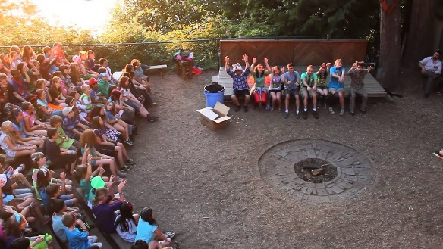
Students gather around the fire pit at Camp Colman.
Courtesy of Google Images

Later that year the butterflies returned as all students entered an unfamiliar, new home. Most of the current students either attended Beaver Lake Middle School or the far superior Pine Lake Middle School. For the first time, students had homework coming in from all different sides and were forced to give up recess cold turkey. Despite this, middle school provided a much-needed gap between being a kid and a young adult. For many this was a confusing time just as the teachers warned us it would be. Middle school also gave students their first glimpse of school dances as well as representing a school in athletics or with music. In 2016 it was time for the seniors to unknowingly have their last formal graduation and finally move towards the final chapter in this long journey. Going into high school, students were no longer the leaders of the school and were now the small and nervous freshman that can be seen at the beginning of every school year. The first roll call introduced students to the spirit of the school and proved the freshman were overmatched by the stomping of the feet, the drums, and the “senior power” chants of that year’s upper classmen. Freshman year introduced some students to the idea of a formal dance through the combination of homecoming and TOLO. These were some great opportunities to have fun with classmates and to see adult teachers dressed up in costumes while playing games at the Family Fun Center. Students got involved with the school through sports, clubs, music, or theater and allowed them to make an impact in the community. A crucial part of student life was grabbing an issue of the school newspaper called The Forum. Every month each student would grab an issue of The Forum and continue to read it front to back and analyze the quality of each article. Three and a half years of high school had led the current seniors to the home stretch, many of whom had been counting down the days since September. Some people assume that the highlight of high school and the last hurrah is prom and for most of the class of 2020, they will have to take their word for it. For the current seniors, a lot is still unknown and it will be interesting to see how everything pans out. For now the most that can be done is to stay healthy, hope for the best, and know that the virus may have taken away some opportunities but it cannot take away the memories that were made along the way.
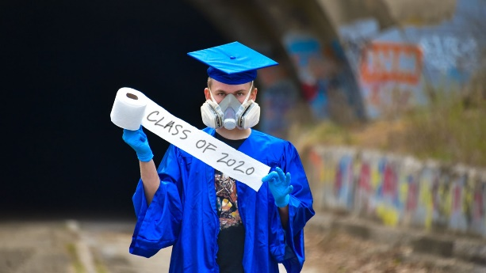
A student wears a mask and holds toilet paper as he graduates.
Courtesy of Google Images

