Blame Game: Who killed Gatsby? Name: __________________________________
Character Name | To what extent are they to blame for Gatsby’s death? | Quote supporting claim (with page number)
Nick Carraway
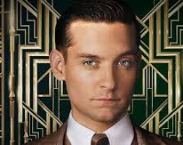
Jay Gatsby
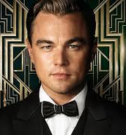
Daisy Buchanan
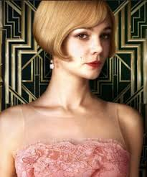
Tom Buchanan
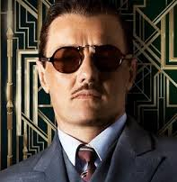
Jordan Baker
Myrtle Wilson
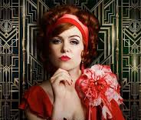
George Wilson 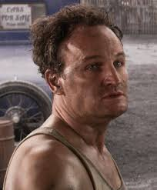
Meyer Wolfsheim
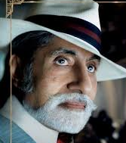
Anyone else to blame? Explain:

Blame Game Reflection Questions (to do after the Blame Game on 12/10)
- Justify who is most to blame for Gatsby’s death/fate.

- To what extent does Gatsby die thinking he achieved his dream?

- Conclude what would be an appropriate ending for the novel. Conclude what would be a ‘happy ending’ for the novel.

- To what extent does Gatsby’s death represent Fitzgerald's views of the 1920s?

- How does Fitzgerald use the novel to share his views of wealth and morality in the 1920s?

- Investigate whether the story needs to take place in the 1920s, or if it could happen in 2019 America.

- Determine the meaning of the last line: “So we beat on, boats against the current, borne back ceaselessly into the past”.

